**Run Python in Power Bi:**

**Steps:**

1. Download Python from this link: <https://www.python.org/downloads/>

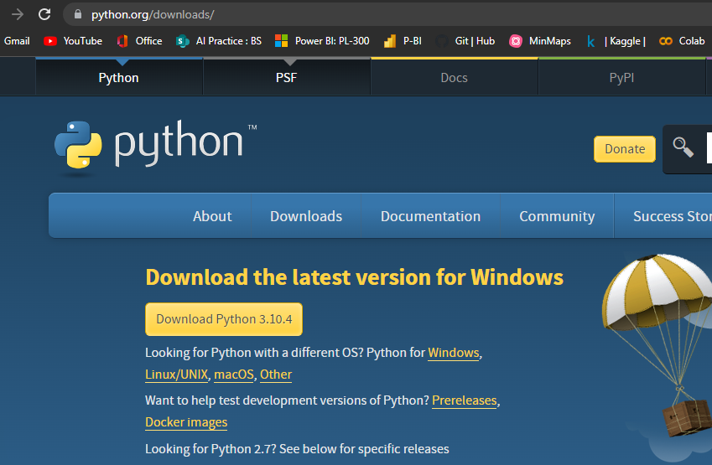

1. Install python executable from the download location:

C:\Users\DharmendraGa_5wskc\Downloads\python-3.10.4-amd64.exe

1. After Python installation,

Installed Python Path: C:\Users\DharmendraGa_5wskc\Downloads\python-3.10.4-amd64.exe

1. Set Python path in Power Bi

Power Bi -> File -> options and settings -> options -> Python Scripting ->

{'Detected Python Home Directories’: 'C:\Users\DharmendraGa_5wskc\AppData\Local\Programs\Python\Python310'}

1. Add Python visual in Power Bi

* Click Py in Visualizations pane:

* Enable Script Visuals: A window pop up, click enable

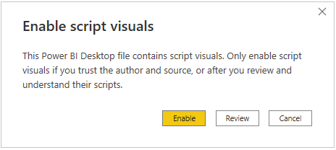

* Python Script Editor window opens, write python code in python script editor window

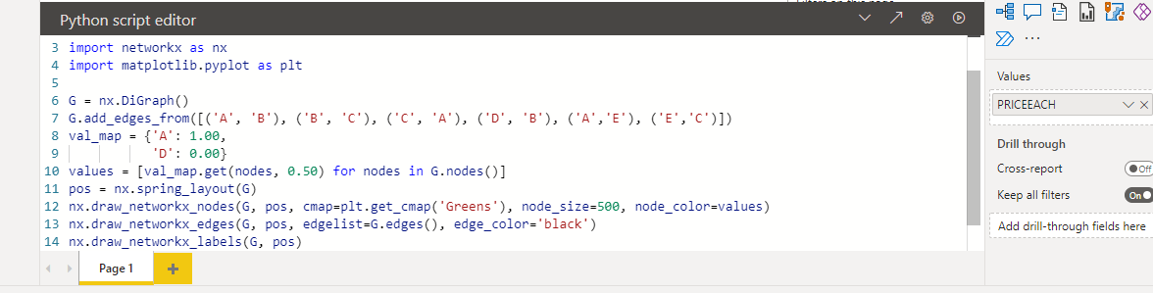

* Drag/Select the columns from tables from fields pane
* run the code by clicking the run button at top right corner of python script editor window

**Tasks:**

1. Execute given graph code in jupyter notebook

* Install the networkx module for graphs implementation
* Write python code in jupyter for creating a graph

1. Implement graph code in Power Bi

* After completing above steps in power bi
* Click Py in Power Bi visualizations pane
* Write code in python script editor window
* Execute code by clicking run button which appear top right corner of python script editor window

1. Save three reports in any image format using python

* Created 3 graphs in power bi using python
* Exported first graph as image in .png format
* Exported second graph as image in .jpg format
* Exported third graph as image in .jpeg format